**Meeting with Dr Yang Tao from A* Star I2R at 1150 HRS to 1300 HRS on 9 Feb 2019**

**Data Explanation:**

**122**: Starting of right motor imagery (subject is instructed to imagine a right/hand limb movement)

**125**: Starting of Idle state (subject is instructed to clear her mind, remain in idling).

**199**: End of motor imagery.

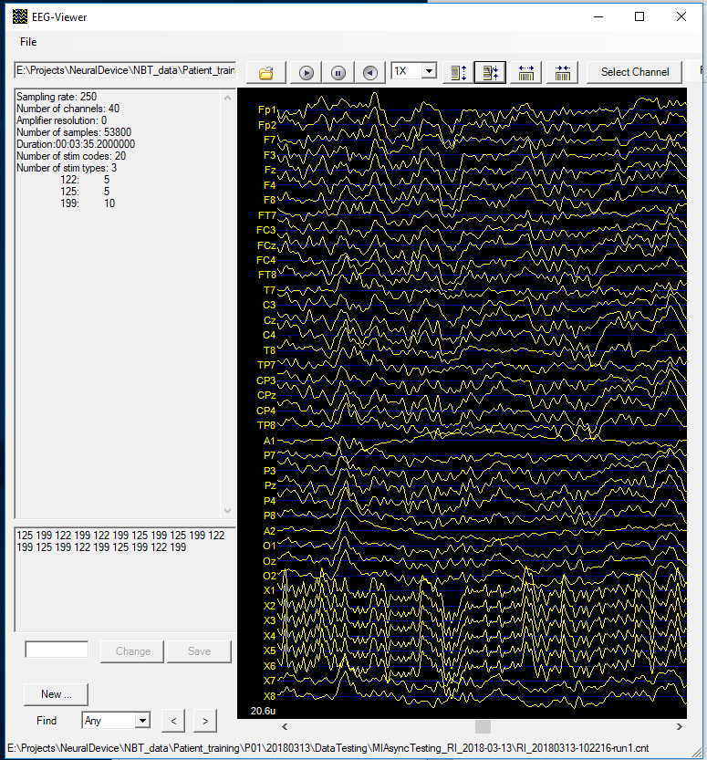

Noted Observations:

ALS patient was told to imagine right limb movement. In general, EEG model was trained with 5 sets of data in a day and tested on 5 sets of data in the same day. Motor-imagery data differs for the patient from day-to-day and week-to-week.

**Why ALS patient was chosen?**

ALS patient is immobile except being able to open eye lip slowly. Absence of motion artefacts which enable us to study EEG wave/signal belonging to mental activity, such as motor imagery. We categorise 0 to 4 Hz as motion artefacts and beyond 4 Hz are other signals.

**Possible Project Steps**

1. Conduct literature review on **inter-subject** motor-imagery classification models and on **single subject** classification models. M. Arvaneh, C. Guan, K. Ang and C. Quek. **Do not** limit ourselves to these scientists and researchers only.
2. Pre-process data
   1. Remove bad trials based on observation
   2. Use a rule-based method to remove noise (i.e. EEG wave above 100 mV)
   3. Check that dataset does not have motion artefacts
   4. Check for singularity to remove data that is suspected short circuit
3. Deep Learning approach such as convolutional neural nets.
4. Prepare image using Filter Band Common Spatial Pattern (FBCSP) method and decoding of signal
5. Place all data (30 channels) into a 6 x 5 black-white image.
6. Train, Validate and test deep learning model on ALS patient dataset
7. We can use deep learning to obtain a transformation matrix for each subject. Transfer learning to another subject if possible.
8. Develop/Optimize/Tune a generic model for the patient
9. Further work: identify optimum frequency bands for correlation of spectral energy graphs